Exercise
- (i)
Null hypothesis (H0): The probability of customers choosing each snack type (A, B, C, D) is equal .
Alternative hypothesis (H1): The probabilities of customers choosing the snack types are not all equal.
(ii)
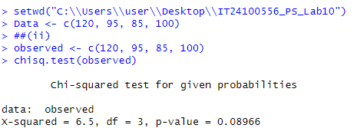
(iii)
Since the p-value(0.08966) is greater than 0.05, don’t reject the null hypothesis at 5% of siginificance level. Therefore, we can conclude that customers choose the four snack types with equal probability.

